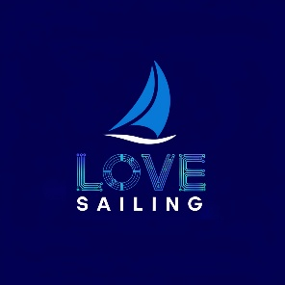

TEST WAIVER 2
YOUTH REGATTA PARTICIPATION & LIABILITY WAIVER
Page 1 — Acknowledgment & Assumption of Risk
Sailing and regatta participation involve risks including but not limited to: changing wind and water conditions, collisions, capsizing, falling overboard, equipment failure, weather hazards (including lightning, heat and hypothermia), physical injury, drowning, or death.
By signing this form, I acknowledge these risks and confirm that the participant:
- Is physically and mentally fit to participate
- Can swim and tread water unassisted
- Will wear a USCG-approved life jacket at all required times
- Will follow all rules, instructions, and safety guidelines
I understand that failure to follow safety instructions may result in the participant being removed from the event without refund.

Page 2 — Medical Consent & Release of Liability
Medical Authorization:
In the event of injury or emergency, I authorize regatta staff, volunteers, and coaches to administer basic first aid and arrange professional medical treatment if necessary. I agree to assume all resulting medical costs.
Known Allergies/Conditions: ________________________________________
Medications: _______________________________________________________
Date : ____________________
Release of Liability:
To the fullest extent allowed by law, I waive and release the event organizers, host club, coaches, volunteers, officers, race officials, and associated facilities from any and all liability for injuries, damages, or losses arising from participation, except in cases of gross negligence or intentional misconduct.
Media Release:
I grant permission for photos/video of participant to be used for event or club promotion unless I initial here to decline: _______

Page 3 — Responsibilities, Conduct & Signature
Parent/Guardian Responsibilities:
I am responsible for transportation, sunscreen, hydration, proper clothing, and timely pickup.
Participant Conduct Expectations:
The participant agrees to:
- Treat others respectfully
- Wear life jackets at required times
- Follow instructions from race officials and safety personnel
- Maintain safe and appropriate behavior at all times
Agreement:
By signing below, I acknowledge that I have read this waiver, understand its terms, and agree to be bound by it. I am signing freely and voluntarily.
Parent/Guardian Name (Print): ______________________________________
Signature: _____________________________________ Date: __________
Participant Name (Print): _________________________________________
Participant Signature (if able): _____________________ Date: ______
Emergency Contact: ___________________________
Phone: _________________________

